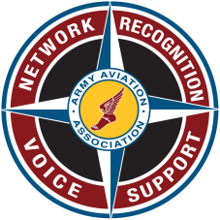
AAAA KEYSTONE CHAPTER

Quarterly Meeting and Social

WHEN:
Friday, 16 March 2018
1630-1800

WHERE:
“104th Regimental Room – 28th ECAB BLDG 19-119”
(Annville, PA)

MEETING DETAILS:
The Keystone Chapter Meeting will take place in the 104th Regimental Room in conjunction ECAB IDT and is aimed at promoting joint participation with the regimental mess. The Keystone Chapter Meeting is for Regimental Mess Members and AAAA members and guests and will commence at 1630 with the formal meeting at 1700. Beverages and snacks to be provided by the Keystone Chapter in the Regimental Room!

* Dress code: Duty Uniform / Business casual.

POC:
MAJ Aaron J. Lippy: (717) 861-9910
or aaron.j.lippy.mil@mail.mil

