WASHINGTON-POTOMAC CHAPTER
WASHINGTON-POTOMAC, AAAA SCHOLARSHIP Golf Tournament

“CAPTAIN’S CHOICE”

SCHOLARSHIP GOLF TOURNAMENT

FRIDAY, 22 June 2018

0800 Hrs Shotgun Start

Gunston Golf Course, Ft Belvoir, VA
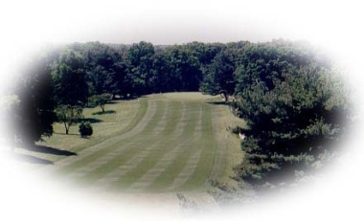
The Washington-Potomac Chapter of AAAA has arranged a Captain's Choice Golf Tournament for Friday, 22 June 2018, at the Gunston Golf Course, Ft Belvoir, VA Golf Club, Ft Belvoir, Virginia, to benefit the Chapter’s Scholarship Fund.

The Tournament will begin with a “Shotgun” Start at 0800 hrs. The Chapter will host up to 32 teams or up to 128 players. We expect to be able to service all comers, however, do not wait to sign up as the acceptance of your reservation will be on a first-come basis.

The cost for this tournament is $100 per player, $390 per foursome (same as last year), which includes: greens fee, cart, range balls, door prizes, unlimited soft drinks and water, a BBQ lunch and prizes (1st, 2nd, 3rd place; men and women’s longest drive and “closest to pin”). A $20.00 Individual 4 Mulligan package will be paid for separately. A limited number of Rental Clubs will be available at $15.00 per set.

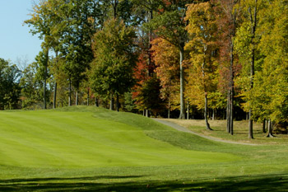
GUNSTON GOLF COURSE, FT BELVOIR, VA,
8450 Beulah St, Bldg 2920,
Ft Belvoir, VA 22060;
(703) 806-5878; http://www.belvoirgolf.com
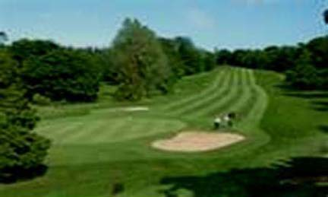
Directions for players with valid US Government Identification Cards: From the North: Take 95 South, exit at Newington/Fort Belvoir Exit (166A). You will be on Fairfax County Parkway. Turn left on John J. Kingman Road. Continue thru the Gate and turn left onto Beulah Street (Rt. 613). The Clubhouse will be on your left.

If going south on Route 1, turn right on Fairfax County Pkwy. Continue and make a right onto John J. Kingman Road. Go thru the Gate. Turn left onto Beulah Street. The clubhouse will be on your left.

From the South: Take 95 North exit at Newington/Fort Belvoir Exit (166A). Turn right at the light to Fairfax County Parkway. Turn left on John J. Kingman Road. Continue and make a left onto Beulah Street (Rt. 613). The Clubhouse will be on your left.

Non-DoD players not with a valid US Government Identification Card holder MUST enter at the Tulley Gate off Route 1. Please remember all persons in the car MUST have a valid driver's license, and the driver MUST have a current automobile registration.

Sponsor packages are available: Title Sponsorship Package: Limit 1 @ $1,800 includes two foursomes, two hole sponsorships, special sponsorship banner recognition, Team Mulligans and Company name on each golf cart; Gold Sponsorship Package: Limit 4 @ $1,275 includes one foursome, two hole sponsorship, Team Mulligans and Company name on sponsorship banner; Silver Sponsorship Package: Unlimited @$875 includes one foursome, one hole sponsorship, Team Mulligans and Company name on sponsorship banner; Individual/Corporate Hole Sponsorships: Unlimited @ $375. Corporate Give-Aways are welcome and encouraged. All fees, above the cost of the golf package, go 100% to scholarships.

Your reply is requested before, but not later than,
15 June 2018. Payment is due with the application and is fully refundable until 15 June 2018. Please send the below form with your check, payable to the Washington-Potomac Chapter, AAAA, to: Washington-Potomac Chapter, ATTN: Jon Hipp , PO Box 1117, Ft Myer, VA 22211-0117. Questions regarding the Tournament or Sponsorships should be directed to Jon Hipp; (O) 703-607-9752 or (Cell) 1-580-574-9253; golf.chairman@wpc-aaaa.org
(Detach and return to the address above NLT 27 April 2018)

“CAPTAIN’S CHOICE” GOLF TOURNEY REGISTRATION FORM

I would like to play in the 22 June 2018 Washington-Potomac AAAA “Captain’s Choice” Scholarship Golf Tournament.

My handicap is ____; No handicap, but my average 18-hole score is __________.

____ Yes, I would like to sponsor a hole(s) ____ ____ Sponsor Form is attached.

If you have already formed a team please list the other members (and handicaps): ____________________________________________________________________________________________________________________________________________________________________________

Name: _____________________________________

Address: ___________________________________

City, State & Zip: ____________________________

Telephone (incl. Area Code): ___________________

Email: ___________________________________

Club Rentals: Men’s Right-handed ____ (# of Sets)
($15.00 per set) Lady’s Right-handed____ (# of Sets)
Men’s Left-handed ____ (# of Sets)
Lady’s Left-handed ____ (# of Sets)
My Check # ______for $________ is enclosed or

I would like to charge $_______ to my VISA __, MasterCard__, Discover__ Debit/Credit Card
#: _ _ _ _ - _ _ _ _ - _ _ _ _ - _ _ _ _
(No AMEX please) Billing ZIP Code: _ _ _ _ _
Exp date: _____ 3 Digit Code on the back: ______

Signature __________________________________

